I am trying to deploy my microservices into Kubernetes cluster. My cluster having one master and one worker node 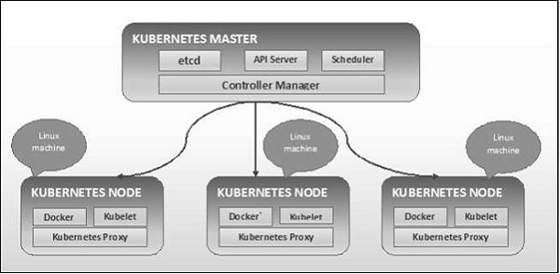

Building the Kubernetes master with below script

Step 1: Build the EC2 instance on AWS environment and do SSH and enter the below script

1. sudo apt-get update
2. sudo apt-get install docker.io -y
3. systemctl enable docker.service
4. sudo apt-get update
5. sudo apt-get update && sudo apt-get install -y apt-transport-https gnupg2 curl
6. curl -s https://packages.cloud.google.com/apt/doc/apt-key.gpg | sudo apt-key add -
7. echo "deb https://apt.kubernetes.io/ kubernetes-xenial main" | sudo tee -a /etc/apt/sources.list.d/kubernetes.list
8. sudo apt-get update
9. sudo apt-get install -y kubectl

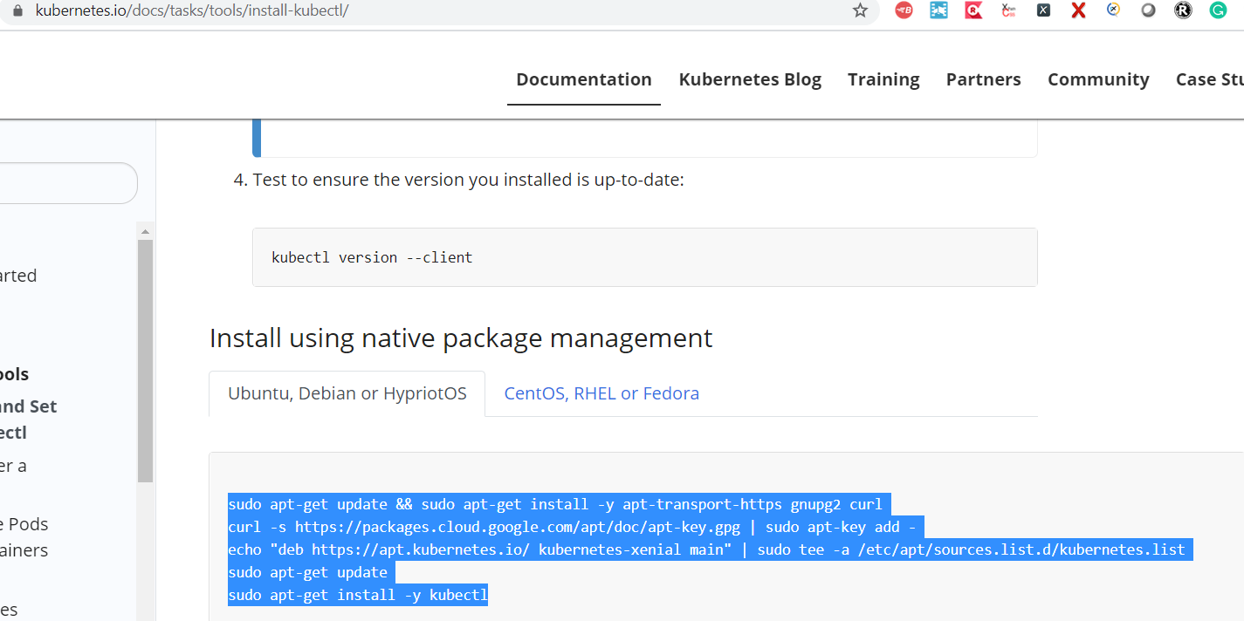

1. sudo apt-get update
2. sudo apt-get install -y kubectl
3. Sleep 90
4. apt-get update
5. sudo apt-get install -y kubeadm kubectl kubelet
6. kubeadm init

<https://kubernetes.io/docs/tasks/tools/install-kubectl/>

<https://docs.projectcalico.org/getting-started/kubernetes/microk8s>

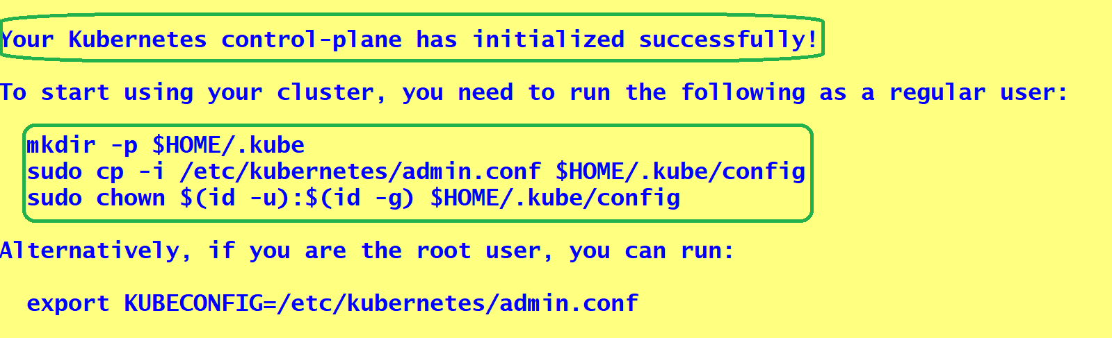

kubectl get pods --all-namespaces

<https://docs.projectcalico.org/archive/v3.17/getting-started/kubernetes/quickstart>

Install calico

kubectl create -f <https://docs.projectcalico.org/archive/v3.17/manifests/tigera-operator.yaml>

kubectl get pods --all-namespaces

kubectl cluster-info

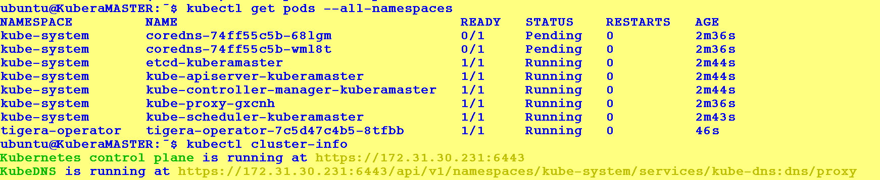

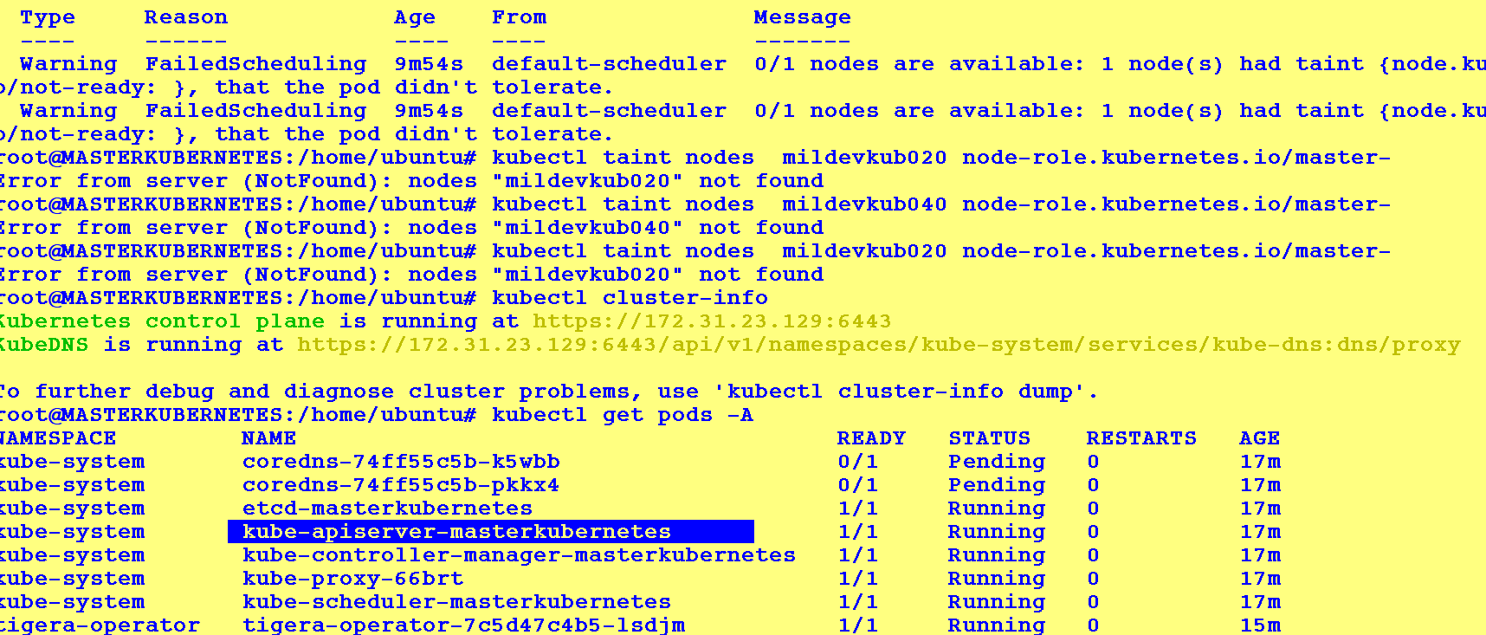

Setting up of Master Node is successful

===============================================================

Building the k8s nodes 1

Take the EC2 machine – and set the required things and set it up in another available zone.

sudo apt-get update

sudo apt-get install docker.io -y

systemctl enable docker.service

sudo apt-get update

1. sudo apt-get update && sudo apt-get install -y apt-transport-https gnupg2 curl
2. curl -s https://packages.cloud.google.com/apt/doc/apt-key.gpg | sudo apt-key add -
3. echo "deb https://apt.kubernetes.io/ kubernetes-xenial main" | sudo tee -a /etc/apt/sources.list.d/kubernetes.list
4. sudo apt-get update
5. sudo apt-get install -y kubectl

sudo apt-get install -y kubeadm kubectl kubelet

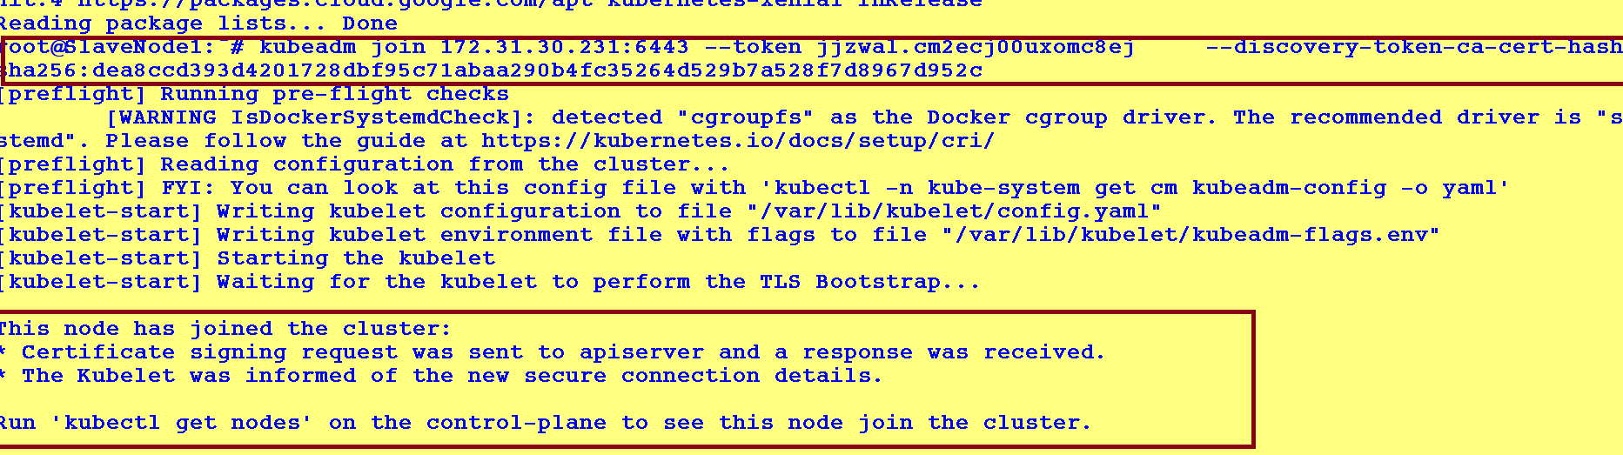

**GO BACK TO MASTER**

sudo su –

kubeadm token create --print -join-command



Established communication between master and slave